Investing in Your Attendance at GWS

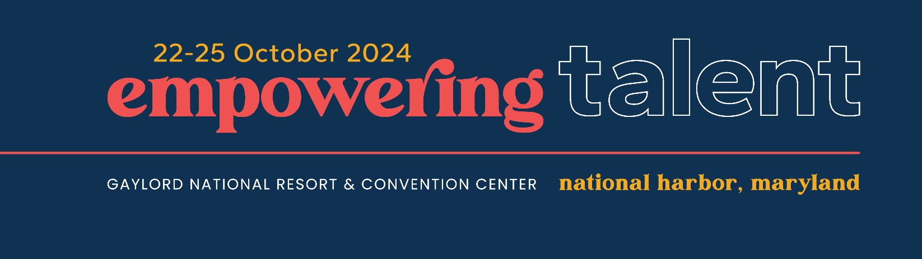

We understand that budgets are tight, and we’re here to help you develop a strong justification for attending GWS 2024. Use the information below to demonstrate the value for your company to invest in your attendance.

**Commit to Continuous Learning:** WERC continues to raise the bar to ensure that GWS is *THE* industry’s source for education, community, and advocacy. Fulfilling our commitment as an association “by the people, for the people,” relevant, timely, and meaningful content has been curated by your peers on the GWS planning committee. Programming focuses on current trends and industry challenges with subject matter experts from the following areas providing knowledge, insights, and innovative solutions for effective mobility management:

* AI, Data Automation, and Predictive Analytics
* Environmental Sustainability
* Expat Services
* Immigration
* Programs and Policies
* Real Estate
* Remote Work
* Talent Management/Human Factors
* Tax
* Technology

You are in the driver’s seat – build your own conference experience by mixing and matching sessions based on discrete areas of interest and specialization. You can also select sessions that match your experience level – novice through advanced. The programming includes thought leadership sessions, hands-on workshops with tangible work products, and several invitation-only events for corporates (e.g., breakfasts, roundtables, labs, etc.).

Our time together will leave you feeling refreshed, engaged, and eager to take on new challenges, powered by an inspiring opening session with internationally renowned culinary innovator José Andrés.

**Build on Your Professional Designations:** Throughout the event, you’ll have opportunities to earn 10+ credits toward the Certified Relocation Professional (CRP®) Certification and the Global Mobility Specialist, Talent Management (GMS-T®) Designation. Earning and maintaining these designations provides recognition of your expertise in global talent mobility. Not yet certified but interested? A lunch-and-learn session will be available to gain more information about these programs.

**Hone-in on Networking and Community:** Leverage the WERC community and exchange best practices with more than 1,600 peers from around the world. Seek expert feedback at corporate-only sessions or make quality connections with other practitioners during our first-timer, solo traveler, and dinner buddy programs.

In need of a new partner? Accelerate your RFP process by setting up service partner meetings and tapping into a qualified network of 75 key service partners.

The GWS schedule has been strategically designed with your business in mind, allowing for 1:1 or group conversations. This includes networking areas and a dedicated corporate benchmarking roundtable session.

Beyond problem-solving and partner meetings, you’ll make genuine connections that can flourish well beyond your time at GWS. This is the place to connect with the people who understand you and your business best.

**Influence Policymakers:** WERC is organizing an Advocacy Day on 22 October for GWS attendees. Join other talent mobility professionals to meet with U.S. House and Senate policymakers on issues critical to talent mobility, including the Moving Tax Expense Deduction Reinstatement, Employment-Based Immigration, and Data Security.

**Celebrate Excellence:** Come to learn, stay to be inspired. WERC will recognize and celebrate excellence in the global talent mobility field with the industry’s most respected awards program. Plus, this year isWERC’s 60th anniversary! Whether you’ve been with us for decades or are just getting started, everyone plays a role in our collective success. We can’t wait to mark this occasion with you at GWS.

**Tips to Make a Strong Case for Attending**

Creative solutions can help you get your request approved. Consider these options:

* Before meeting with your supervisor or approver, prepare a plan that shows who will cover your regular duties while you attend this event.
* Present a cost-benefit analysis. Use the worksheet on the next page to help determine the full cost of attendance and identify the benefits you and your organization will gain.
* Draft a formal (and persuasive) request for funding using the justification letter on the last page.
* Offer to prepare and deliver a short presentation and Q&A session for your colleagues to share what you learned. This way, your coworkers will also benefit from your attendance.
* Share speaker handouts with your colleagues. As an attendee, you will have access to presenter materials that are easily downloadable once you return home.

[Contact WERC staff](mailto:customersuccess@worldwideerc.org?subject=GWS%202024%20Justification%20Resources) if you need additional information or support.

We look forward to seeing you in October at the Gaylord Resort & Convention Center in National Harbor, Maryland!

**Step 1: Determine the Costs**

Use this worksheet to estimate the total cost of your attendance. All fees are listed in USD.

|  |  |
| --- | --- |
| **Registration Cost**  If you are a **Corporate Mobility/HR Professional:** WERC provides up to two (2) complimentary corporate/government registrations per company for GWS 2024, as part of the Corporate Mobility WERC Access Program. If you have additional corporate HR professionals who would like to attend, registrants are eligible to purchase an additional registration at a discounted rate of $892.50 (50% off the early-bird rate). One of the registrants must be an overall program leader for a global or domestic mobility program.  If you are a **Government Employee:** WERC provides up to two (2) complimentary registrations per government agency for GWS 2024, for government employees responsible for relocation policy, program management, or contracting relocation services. If you have additional agency employees who would like to attend, registrants are eligible to purchase an additional registration at a discounted rate of $892.50 (50% off the early-bird rate). The complimentary registration has a value of up to $2,195 per registrant. | $0 |
| **Flight/Train/Transportation to and from the Washington, D.C., area**  Visit a travel website to estimate your flight, train, or other transportation cost. There are three airports in the National Capital Region: Reagan National Airport (DCA), Dulles International Airport (IAD), and Baltimore-Washington Marshall International Airport (BWI). The Gaylord National Resort & Convention Center is also accessible via Amtrak, with Washington Union Station (WAS) approximately five miles away. | $ |
| **Hotel**  Rooms are available for $299 plus 18% sales tax and a $27 daily resort fee. | $ |
| **Transportation from the Airport**  The Gaylord National Resort & Convention Center is most easily accessible from the Reagan National Airport (DCA) by Uber, Lyft, and taxi. The following estimates will help you plan your trip: Lyft/Uber at $35 and taxi at $40.  The prices listed above are estimates; actual costs will vary depending on time of day and demand. Rates will also vary if attendees arrive from other airports in the National Capital Region. | $ |
| **Parking Information**  Parking is available at the following rates: Hourly at $19 and daily at $39. | $ |
| **Meals**  Use this section to calculate the cost of meals for your trip. Lunch will be provided for all attendees on Wednesday and Thursday. Breakfast is provided for those attending through the [Corporate Mobility WERC Access Program](https://werc.swoogo.com/GWS) on Wednesday. | $ |
| **Subtotal Per Person** | $ |
| **Total Number of Employees Attending** |  |
| **Total Cost** | $ |

**Step 2: Outline the Benefits**

When showcasing the benefits of attending GWS 2024*,* focus specifically on what benefits you will bring back to your company or agency as a return on their investment.

* How can networking open doors for your business? Could the people you meet help your organization achieve cost savings and efficiencies while maintaining a positive experience for assignees?
* Which sessions can teach you a skill or solution that will help your team overcome current or future challenges?
* Are there any speakers your organization would benefit from hearing from or working with?
* What value would you get from attending one or more of the roundtables, breakout sessions, or labs/workshops?

When considering these questions, keep these tips in mind:

* List specific sessions/networking events you plan to attend and explain how they will impact you and your organization.
* Make the connection between your organization’s needs and the benefits you are identifying.
* Passion is the best persuasion technique—let yours shine through.

**Step 3: Draft Your Letter**

Customize this template to explain the benefits of attending GWS 2024.

Dear **<Approver’s Name>**,

I would like to attend [GWS 2024](http://www.gws2024.org), taking place 22-25 October 2024, at National Harbor, Maryland, near Washington, D.C.

With more than 1,600 global talent mobility practitioners and service providers in attendance, I will have countless opportunities to connect with and learn from my peers, as well as leading industry experts from around the world.

Attending GWS 2024 will provide insights into the latest trends, newest solutions, and industry best practices, as well as access to a powerful network of global talent mobility professionals. I will also find new resources and approaches to address our biggest challenges and opportunities. Specific examples include X, Y, and Z.

I am confident that the lessons learned from these sessions and the insights from the rest of the educational program will position us for success into 2025 and beyond.

Through WERC’s Corporate Mobility Access Program, my registration fee is waived.

That is a total savings of **$2,195** for [me/each one of us] that is already covered. I am requesting **<total amount>** for the following expenses:

Round-trip Airfare/Train/Other Transportation: **<$xxxx>**  
Ground Transportation: **<$xxxx>**  
Hotel: **<$xxxx>**  
Meals: **<$xxxx>**

Please let me know if you have any questions or would like more information.

Sincerely,

**<Your Name Here >**