Investing in Your Attendance at GWS

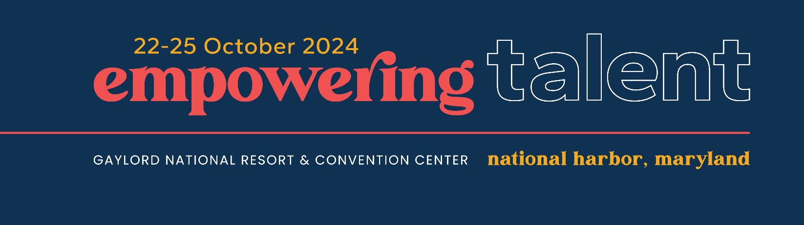

We understand that budgets are tight, and we’re here to help you develop a strong justification for going to GWS 2024. Use the information below to demonstrate the value for your company to invest in your attendance.

Commit to Continuous Learning: WERC continues to raise the bar to ensure that GWS is THE industry’s source for education, community, and advocacy. Fulfilling our commitment as an association “by the people, for the people,” relevant, timely, and meaningful content has been curated by your peers on the GWS planning committee. Programming focuses on current trends and industry challenges with subject matter experts from the following areas providing knowledge, insights, and innovative solutions for effective mobility management:

- AI, Data Automation, and Predictive Analytics
- Environmental Sustainability
- Expat Services
- Immigration
- Programs and Policies
- Real Estate
- Remote Work
- Talent Management/Human Factors
- Tax
- Technology

You are in the driver’s seat – build your own conference experience by mixing and matching sessions based on discrete areas of interest and specialization. You can also select sessions that match your experience level – novice through advanced. The programming includes thought leadership sessions and hands-on workshops with tangible work products to maximize the impact on your career and business.

Our time together will leave you feeling refreshed, engaged, and eager to take on new challenges, powered by an inspiring opening session with internationally renowned culinary innovator José Andrés.

Build on Your Professional Designations: Throughout the event, you’ll have opportunities to earn 10+ credits toward the Certified Relocation Professional (CRP®) Certification and the Global Mobility Specialist, Talent Management (GMS-T®) Designation. Earning and maintaining these designations provides recognition of your expertise in global talent mobility. Not yet certified but interested? A lunch-and-learn session will be available to gain more information about these programs.

Hone-in on Networking and Community: Nearly half (43%) of attendees hold purchasing authority in their companies. Leverage the WERC community to strengthen your business and tap into a vast universe of more than 1,600 high-quality customers from around the world. Strike up new partnership opportunities and deepen existing ones, compare business trends and market notes with your peers and partners, and make quality connections with professionals who could become your next client or team member.

You’ll make genuine connections that can flourish well beyond your time at GWS. This is the place to connect with the people who understand you and your business best.

Influence Policymakers: WERC is organizing an Advocacy Day on 22 October for GWS attendees. Join other talent mobility professionals to meet with U.S. House and Senate policymakers on issues critical to talent mobility, including the Moving Tax Expense Deduction Reinstatement, Employment-Based Immigration, and Data Security.

Celebrate Excellence: Come to learn, stay to be inspired. WERC will recognize and celebrate excellence in the global talent mobility field with the industry’s most respected awards program. Plus, this year is WERC’s 60th anniversary! Whether you’ve been with us for decades or are just getting started, everyone plays a role in our collective success. We can’t wait to mark this occasion with you at GWS.

Tips to Make a Strong Case for Attending

Creative solutions can help you get your request approved. Consider these options:

- Before meeting with your supervisor or approver, prepare a plan that shows who will cover your regular duties while you attend this event.
- Present a cost-benefit analysis. Use the worksheet on the next page to help determine the full cost of attendance and identify the benefits you and your organization will gain.
- Draft a formal (and persuasive) request for funding using the justification letter on the last page.
- Offer to deliver a short presentation and Q&A session for your colleagues to share what you learned and who you connected with. This way, your coworkers will also benefit from your attendance.
- Share speaker handouts with your colleagues. As an attendee, you will have access to presenter materials that are easily downloadable once you return home.

Contact WERC staff if you need additional information or support. We look forward to seeing you in October at the Gaylord Resort & Convention Center in National Harbor, Maryland!

Step 1: Determine the Costs

Use this worksheet to estimate the total cost of your attendance. All fees are listed in USD.

Registration Cost  Service Providers who are WERC members receive a registration discount. Savings are also available based on the timing of registration, as noted in the table below.  Through 27 August 28 August – 14 October After 15 October  Member $1,785 $1,965 $2,195  Non-Member $2,185 $2,365 $2,595 | $
Flight/Train/Transportation to and from the Washington, D.C., area  Visit a travel website to estimate your flight, train, or other transportation cost. There are three airports in the National Capital Region: Reagan National Airport (DCA), Dulles International Airport (IAD), and Baltimore-Washington Marshall International Airport (BWI). The Gaylord National Resort & Convention Center is also accessible via Amtrak, with Washington Union Station (WAS) located approximately five miles away. | $
Hotel  Rooms are available for $299 plus 18% sales tax and a $27 daily resort fee. | $
Transportation from the Airport  The Gaylord National Resort & Convention Center is most easily accessible from the Reagan National Airport (DCA) by Uber, Lyft, and taxi. The following estimates will help you plan your trip: Lyft/Uber at $35 and taxi at $40.  The prices listed above are estimates; actual costs will vary depending on time of day and demand. Rates will also vary if attendees arrive from other airports in the National Capital Region. | $
Parking Information  Parking is available at the following rates: Hourly at $19 and daily at $39. | $
Meals  Use this section to calculate the cost of meals for your trip. Lunch will be provided for all attendees on Wednesday and Thursday. | $
Subtotal Per Person | $
Total Number of Employees Attending
Total Cost | $

Step 2: Outline the Benefits

When showcasing the benefits of attending GWS 2024, focus specifically on what benefits you will bring back to your company or agency as a return on their investment.

- How can networking open doors for your business?

- Which sessions can teach you a skill or solution that will help you or your team?

- Are there any speakers your organization would benefit from hearing from or working with?

- What value would you get from attending one or more of the roundtables, breakout sessions, or labs/workshops?

When considering these questions, keep these tips in mind:

- List specific sessions/networking events you plan to attend and explain how they will impact you and your organization.
- Make the connection between your organization’s needs and the benefits you are identifying.
- Passion is the best persuasion technique—let yours shine through.

Step 3: Draft Your Letter

Customize this template to explain the benefits of attending GWS 2024.

Dear <Approver’s Name>,

I would like to attend GWS 2024, taking place 22-25 October 2024, at National Harbor, Maryland, near Washington, D.C.

With more than 1,600 global talent mobility practitioners and service providers in attendance, I will have countless opportunities to connect with and learn from my peers, as well as leading industry experts from around the world.

Attending GWS 2024 will provide insights into the latest trends, newest solutions, and industry best practices, as well as access to a powerful network of global talent mobility professionals. Last year, nearly half (43%) of attendees reported having purchasing authority in their companies, making this event a prime opportunity to forge new and meaningful partnerships. I will also find new resources and approaches to address our biggest challenges and opportunities. Specific examples include X, Y, and Z.

I am confident that the takeaways I gain will position us for success into 2025 and beyond.

I am requesting <total amount> for the following expenses:

Registration: <$xxxx>
Round-trip Airfare/Train/Other Transportation: <$xxxx>
Ground Transportation: <$xxxx>
Hotel: <$xxxx>
Meals: <$xxxx>

Please let me know if you have any questions or would like more information.

Sincerely,
<Your Name Here >

